

BLACK ROOM INTELLIGENCE LTD | BLACKROOMINTELLIGENCE.COM
PRODUCED FOR COMPANY NAME
CLIENT OVERVIEW & ISSUE SUMMARY
BUBBLE DDoS / BOTNET ATTACK

Application/Authentication Denial of Service Investigation
A limited scope cyber investigation took place to try to attribute a recent attempted application level Distributed Denial of Service (DoS) attack to a threat actor. Attributing an attack to a potential cyber threat actor can enable more comprehensive incident management and remediation as the Tools, Tactics, Techniques and Procedures (TTPs) can be understood.

Summary of findings
Black Room Intelligence were provided with eight malicious IP addresses to investigate. By utilising a range of current and historical IP Reputation analysis tools, it was seen that these IP addresses have previously been associated with malicious activities, including malware distribution, ssh brute force and a variety of botnets
- Six IPs were associated with Stark Industries Solutions Ltd, a potentially medium fraud risk ISP by Scamalytics.
- Seven of the IPs had a high fraud risk above 90, as scored by IP Quality Score.
- Spamhaus detected that the IP address 50.2.50.2 initiated contact with a nymaim botnet related command and control server.

Recommendations
In line and active, or on standy, DDoS protection services could be explored which could greatly filter out IP addresses which have a known bad reputation.

Investigation Details
Nymain / Avalanche Botnet
The nymaim / avalanche botnet was taken down in 2016, however the malware associated with it remains active. The 50.2.50.2 IP address appears to be part of multiple botnets and has a history of abusive behaviour. With respect to Stark Industries Solution this virtual server hosting company is a bulletproof host with connections to Russia.
Noname Botnet
The use of Stark Industries Solutions may also be associated with the Noname057(16) botnet, a pro-Russian hacktivist group involved in developing Project DDoSia. This threat actor group conducts large-scale DDoS attacks against entities supporting Ukraine, predominantly NATO member states.

FINDINGS
INVESTIGATIONS

This report aims to analyse and document the findings related to the suspected botnet-related DDoS attack on Bubble. The investigation focused on eight IP addresses provided by the client. Analysis included IP ownership details, fraud checks, email associations, location tracking, autonomous system numbers, ISP fraud risk assessments, reverse DNS lookups, and IP reputation scores. Tools used in this investigation include Maltego, DomainTools, Scamalytics, and IP Quality Score.

Location Associated with the IP’s
- 194.156.98.115, Hong Kong
- 94.131.11.221, The Netherlands
- 176.120.74.126, Spain
- 95.164.35.33, Poland
- 5.183.255.219, Russia
- 195.149.87.196, United States

DomainTools Autonomous System Number
- AS44477 Stark Industries Solutions Ltd:
- 194.156.98.115
- 195.149.87.196
- 94.131.11.221
- 95.164.35.33
- 176.120.74.126
- 146.19.247.7
- AS14576 Hosting Solutions: 5.183.255.219
- AS62904: 50.2.50.2
Reverse DNS
- 194.156.98.115, mo.hk.27.04.24
- 94.131.11.221, mo.nl.27.04.24
- 95.164.35.33, mo.pl.27.04.24
- 176.120.74.126, mo.es.27.04.24
- 195.149.87.196, mo.us.27.04.24
- 146.19.247.7, mo.de.27.04.24
- 50.2.50.2, cars.jetszooma.com

IP Quality Score (IP reputation)
- 194.156.98.115 - 100 Abusive IP
- 5.183.255.219 - 100 High Risk - IP address recently used by bots
- 146.19.247.7 - 99 High Risk - IP address recently used by bots
- 176.120.74.126 - 93 High Risk
- 94.131.11.221 - 93 High Risk
- 95.164.35.33 - 93 High Risk
- 50.2.50.2 - 93 High Risk
- 195.149.87.196 - 65 Suspicious

Scamalytics ISP Fraud Risk
Stark Industries Solutions LTD is considered to be a potentially medium fraud risk ISP. They operate 315,117 IP addresses, some of which run anonymizing VPNs. The overall fraud risk is a score of 32.

FURTHER FINDINGS
MALTEGO ANALYSIS

Investigation using Maltego focused on analysing the eight IP addresses provided by the client. The Maltego transforms included IP ownership details, fraud checks, email address associations, and location tracking. Below are the detailed findings from this analysis:

IP Ownership Details
The ownership details for the IP addresses revealed associations primarily with Stark Industries Solutions Ltd, specifically marked by the tags @stark and STARK-MNT. One particular IP address, 50.2.50.2, was found to be linked to a contact phone number 062910001.

Fraud Check on IP Addresses
The fraud risk associated with the IP addresses was assessed using various tools. Four IP addresses exhibited the highest possible fraud score of 100, indicating severe risk and potential involvement in malicious activities.

IP Addresses with Fraud Score of 100:
- 194.156.98.115
- 94.131.11.221
- 176.120.74.126
- 5.183.255.219
These high fraud scores suggest that these IPs have been recently used in malicious activities, such as botnet operations or other forms of cyber attacks.

Associated Email Addresses:
- abuse@ripe.net
- abuse@pq.hosting
- info@traffictransitsolution.us

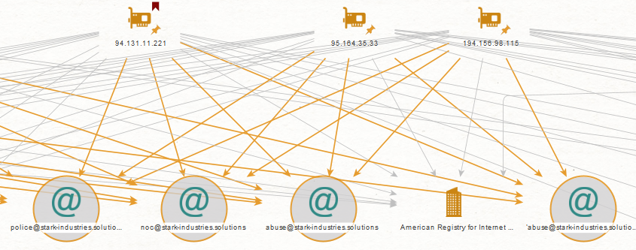

FURTHER FINDINGS
SPAMHAUS & VIRUSTOTAL REPORT

SpamHaus Reputation Checker
50.2.50.2 - infected with malware associated with the avalanche/andromeda family.
50.2.50.2 initiated contact with a nymaim C2 server using source port 54850, to the sinkhole IP address 216.218.185.162 on destination port 80. Detection was on: May 19 2024, 18:30:32 UTC.
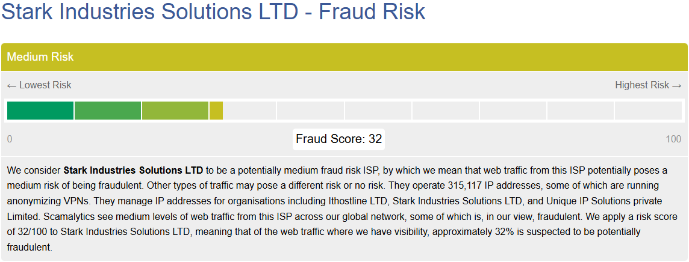

The Andromeda/Avalanche botnet was associated with 80 different malware families: Andromeda, Win3/Dofoil, Gamarue, Smoke Loader, W32/Zurgop.BK!tr.dldr, and many others. The Avalanche network also provided the Command & Control communications for these other botnets: TeslaCrypt, Nymaim, Corebot, GetTiny, Matsnu, Rovnix, Urlzone, QakBot, etc. This botnet was taken down in 2016 but malware associated with it remains active.
VirusTotal Malware -
- 194.156.98.115: Score 1/92 Security vendor flagged for Malware
- 146.19.247.7: Score 1/92 Security vendor flagged for Malware
- 5.183.255.219: Score 1/92 Security vendor flagged for Malware
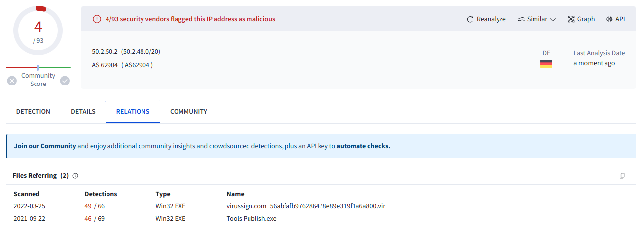
- 50.2.50.2: Score 4/93 Security vendor falgged as malicious
CONCLUSION
IP ADDRESS INVESTIGATION

IP Address: 5.183.255.219 & 194.156.98.115
- Malicious Activity: Identified as a victim of botting for potential automated fraudulent behaviour. These IP address shares bot types commonly used for malicious activities.
- Tor Association: Suspected involvement with the Tor network.
- Brute Force and SSH Attacks: Frequently reported for engaging in brute force and SSH attacks.
- Stark Industries Solutions Ltd: WHOis information associates this IP with Stark Industries Solutions Ltd.
- Recent Abuse History: Recent reports indicate continued malicious behaviour, including confirmed chargebacks, compromised devices, and fake app installs.
IP Address: 50.2.50.2
- Active Abusive Behaviour: Detected and flagged numerous times since 2021 for malicious activities including brute force, SSH attacks, and web app attacks.
- SPAM and Blacklist Entries: Recent activities have triggered SPAM blacklist entries, indicating spam emails and other abusive behaviour.
- VPN Connection: Identified as associated with a VPN connection.
- Physical Address: 3773 Howard Hughes Pkwy. Suite 500S, Las Vegas, NV, 89169-6014, US.

Conclusion:
The association to the Stark Industries VPS hosting service may allow us to attribute this DDoS attack to the Noname057(16) botnet. This botnet is part of a pro-Russian hacktivist group involved in developing and disseminating a DDoS solution known as Project DDoSia. This threat actor is actively engaged in conducting large-scale DDoS attacks against entities and companies supporting Ukraine, predominantly those in NATO member states including the United Kingdom.

For more about Stark Industries Solutions:
"AS44477, associated with STARK INDUSTRIES, operates as a suspected bulletproof host with connections to Russia. The observed activity, particularly the presence of Redline stealer and botnet-related traffic, indicates malicious intent aimed at compromising user data and expanding botnet networks. STARK INDUSTRIES may be operating as a bulletproof hosting provider facilitating cybercriminal activities." - Hyas Threat Intel
Source: https://www.hyas.com/blog/hyas-threat-intel-report-may-6-2024
Noname056(16) botnet blogpost, including reference to STARK-INDUSTRIES: https://blog.sekoia.io/noname05716-ddosia-project-2024-updates-and-behavioural-shifts/
APPENDIX

Bulletproof Hosting: A technical infrastructure service provided by an internet hosting provider that is resilient to complaints of illicit activities. This allows criminal actors to conduct activities despite takedown requests.

Botnet: A group of internet-connected devices that can be used to preform distributed Denial-of-Service attacks, send spam and steal data. The owner of the botnet controls these devices through command-and-control software.

ASN (Autonomous System Number): A unique number assigned to an Autonomous System, which is a collection of connected Internet Protocol (IP) routing prefixes under the control of one or more operators on behalf of a domain or administrative entity. This allows for a common and clear routing policy on the internet.

Maltego: A software tool used for open-source intelligence, forensics, and investigations, allowing for link analysis.

Spamhaus: An international organisation that aims to track email spammers and spam-related activity.

DDoS (Distributed Denial-of-Service): An attack in which multiple compromised computer systems attack a target, such as a server, website, or other network resource, causing a denial of service for users of the targeted resource.

WHOis: A protocol used to query databases that store the registered users or assignees of an Internet resource, such as a domain name, an IP address block, or an autonomous system.

